JOBSHEET 10

TUGAS PRAKTIKUM 1

package jo10;

import java.util.Scanner;

import java.util.Arrays;

public class TugasPraktikum1 {

public static void main(String[] args){

Scanner baca = new Scanner(System.in);

String pencarian, jawaban;

boolean ulang = true;

int x;

String[] siswa = new String[]{"Deanne","Victoria","Erna","Nathalie",

"Pamela","Armand","Omar","Alvaro","Ben","Danny"};

System.out.print("Masukkan nama siswa yang dicari : ");

pencarian = baca.nextLine();

//asList untuk mengambil data dari array siswa

if(Arrays.asList(siswa).contains(pencarian)){

System.out.println("Ditemukan");

}

else {

System.out.println("Tidak ditemukan");

}

while(ulang == true){

System.out.println("");

System.out.println("Ingin mencari data lagi?");

System.out.print("Jawab{ya/tidak}: ");

jawaban = baca.nextLine();

if(jawaban.equalsIgnoreCase("ya")){

ulang = false;

System.out.print("Masukkan nama siswa yang dicari : ");

pencarian = baca.nextLine();

if(Arrays.asList(siswa).contains(pencarian)){

System.out.println("Ditemukan");

ulang = true;

}

else {

System.out.println("Tidak ditemukan");

ulang = true;

}

}

else

{

System.out.println("Terima Kasih");

ulang = false;

}

}

}

}

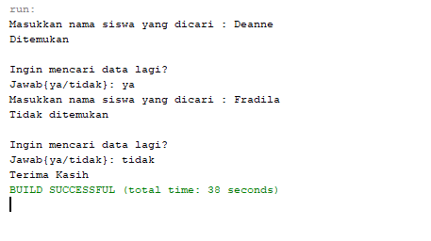

TUGAS PRAKTIKUM 2

package jo10;

import java.util.Scanner;

public class TugasPraktikum2 {

public static int[] angka = new int[6];

public static void main(String[] args) {

String input;

int x;

Scanner baca = new Scanner(System.in);

for(int data=0; data<6; data++) {

System.out.print("Bilangan ke - " + (data + 1) + " : ");

input = baca.nextLine();

x = Integer.parseInt(input);

angka[data] = x;

}

System.out.println("Kelompok Bilangan Genap : ");

Genap();

System.out.println("Kelompok Bilangan Ganjil : ");

Ganjil();

}

public static void Ganjil() {

for(int data=0; data < 6; data++) {

if (angka[data] % 2 == 1){

System.out.print("\t" + angka[data]);

}

}

System.out.println("");

}

public static void Genap() {

for(int data=0; data<6; data++) {

if(angka[data] % 2 == 0){

System.out.print("\t" + angka[data]);

}

}

System.out.println("");

}

}

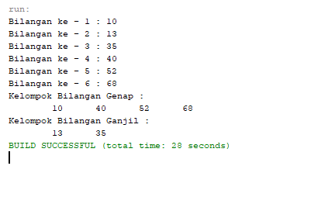

TUGAS PRAKTIKUM 3

